Fundamentals of Machine Learning (FML)
Assignment: 1
(Implementing the 10 Algorithms on MNIST dataset)

I’m writing codes here and will attach the results at the end.
CODES:
- Data Extracting and Pre Processing
import numpy as np
from sklearn.datasets import fetch_openml

# Load MNIST dataset
X, y = fetch_openml('mnist_784', version=1, return_X_y=True, as_frame=False)
y = y.astype(np.uint8)

# Train-test split
X_train, X_test = X[:60000], X[60000:]
y_train, y_test = y[:60000], y[60000:]

# Normalize pixel values
X_train = X_train / 255.0
X_test = X_test / 255.0

# Function to inspect a sample
def show_sample(index, dataset='train'):
if dataset == 'train':
x = X_train[index]
label = y_train[index]
else:
x = X_test[index]
label = y_test[index]

print("Label:", label)
print("First 10 pixels:", x[:10])

img = x.reshape(28, 28)

- Logistic Regression
from sklearn.linear_model import LogisticRegression
from sklearn.metrics import accuracy_score, confusion_matrix
import matplotlib.pyplot as plt
import seaborn as sns
import time

# Model
model = LogisticRegression(max_iter=100, random_state=42, multi_class='ovr', n_jobs=-1)

# Training
start = time.time()
model.fit(X_train, y_train)
train_time_lr = time.time() - start

# Prediction
start = time.time()
y_pred = model.predict(X_test)
pred_time_lr = time.time() - start

# Accuracy
accuracy_lr = accuracy_score(y_test, y_pred)

# Results
print("Training Time:", round(train_time_lr, 2), "sec")
print("Prediction Time:", round(pred_time_lr, 2), "sec")
print("Accuracy:", round(accuracy_lr * 100, 2), "%")

# Confusion Matrix (plot only)
cm = confusion_matrix(y_test, y_pred)

plt.figure(figsize=(8, 6))
sns.heatmap(cm, annot=True, fmt='d')
plt.xlabel("Predicted")
plt.ylabel("Actual")
plt.title("Confusion Matrix")
plt.show()

- K-Nearest Neighbors (KNN)
from sklearn.neighbors import KNeighborsClassifier
from sklearn.metrics import accuracy_score, confusion_matrix
import matplotlib.pyplot as plt
import seaborn as sns
import time

# Model
model = KNeighborsClassifier(n_neighbors=5, n_jobs=-1)

# Training
start = time.time()
model.fit(X_train, y_train)
train_time_knn = time.time() - start

# Prediction
start = time.time()
y_pred = model.predict(X_test)
pred_time_knn = time.time() - start

# Accuracy
accuracy_knn = accuracy_score(y_test, y_pred)

#Results
print("Training Time:", round(train_time_knn, 2), "sec")
print("Prediction Time:", round(pred_time_knn, 2), "sec")
print("Accuracy:", round(accuracy_knn * 100, 2), "%")

# Confusion Matrix (plot only)
cm = confusion_matrix(y_test, y_pred)

plt.figure(figsize=(8, 6))
sns.heatmap(cm, annot=True, fmt='d')
plt.xlabel("Predicted")
plt.ylabel("Actual")
plt.title("Confusion Matrix - KNN")
plt.show()

- Support Vector Machine (SVM)
from sklearn.svm import SVC
from sklearn.metrics import accuracy_score, confusion_matrix
import numpy as np
import matplotlib.pyplot as plt
import seaborn as sns
import time

# Subset (for faster training)

np.random.seed(42)
idx = np.random.choice(60000, 10000, replace=False)
X_sub = X_train_scaled[idx]
y_sub = y_train[idx]

# Model
model = SVC(kernel='rbf', C=1.0, gamma='scale')

# Training
start = time.time()
model.fit(X_sub, y_sub)
train_time_svm = time.time() - start

# Prediction
start = time.time()
y_pred = model.predict(X_test_scaled)
pred_time_svm = time.time() - start

# Accuracy
accuracy_svm = accuracy_score(y_test, y_pred)

print("Training Time:", round(train_time_svm, 2), "sec")
print("Prediction Time:", round(pred_time_svm, 2), "sec")
print("Accuracy:", round(accuracy_svm * 100, 2), "%")

# Confusion Matrix (plot only)
cm = confusion_matrix(y_test, y_pred)

plt.figure(figsize=(8, 6))
sns.heatmap(cm, annot=True, fmt='d')
plt.xlabel("Predicted")
plt.ylabel("Actual")
plt.title("Confusion Matrix - SVM")
plt.show()
- Naïve Bayes
from sklearn.naive_bayes import GaussianNB
from sklearn.metrics import accuracy_score, confusion_matrix
import matplotlib.pyplot as plt
import seaborn as sns
import time

# Model
model = GaussianNB()

# Training
start = time.time()
model.fit(X_train_scaled, y_train)
train_time_nb = time.time() - start

# Prediction
start = time.time()
y_pred = model.predict(X_test_scaled)
pred_time_nb = time.time() - start

# Accuracy
accuracy_nb = accuracy_score(y_test, y_pred)

print("Training Time:", round(train_time_nb, 2), "sec")
print("Prediction Time:", round(pred_time_nb, 2), "sec")
print("Accuracy:", round(accuracy_nb * 100, 2), "%")

# Confusion Matrix (plot only)
cm = confusion_matrix(y_test, y_pred)

plt.figure(figsize=(8, 6))
sns.heatmap(cm, annot=True, fmt='d')
plt.xlabel("Predicted")
plt.ylabel("Actual")
plt.title("Confusion Matrix - Naive Bayes")
plt.show()

- Decision Tree
from sklearn.tree import DecisionTreeClassifier
from sklearn.metrics import accuracy_score, confusion_matrix
import matplotlib.pyplot as plt
import seaborn as sns
import time

# Model
dt = DecisionTreeClassifier(max_depth=20, random_state=42)

# Training
start = time.time()
dt.fit(X_train_scaled, y_train)
train_time_dt = time.time() - start

# Prediction
start = time.time()
y_pred_dt = dt.predict(X_test_scaled)
pred_time_dt = time.time() - start

# Accuracy
accuracy_dt = accuracy_score(y_test, y_pred_dt)

print("Training Time:", round(train_time_dt, 2), "sec")
print("Prediction Time:", round(pred_time_dt, 2), "sec")
print("Accuracy:", round(accuracy_dt * 100, 2), "%")

# Confusion Matrix (plot only)
cm_dt = confusion_matrix(y_test, y_pred_dt)

plt.figure(figsize=(8, 6))
sns.heatmap(cm_dt, annot=True, fmt='d')
plt.xlabel("Predicted")
plt.ylabel("Actual")
plt.title("Confusion Matrix - Decision Tree")
plt.show()

- Random Forest
from sklearn.ensemble import RandomForestClassifier
from sklearn.metrics import accuracy_score, confusion_matrix
import matplotlib.pyplot as plt
import seaborn as sns
import time

# Model
rf = RandomForestClassifier(n_estimators=100, max_depth=20, random_state=42, n_jobs=-1)

# Training
start = time.time()
rf.fit(X_train_scaled, y_train)
train_time_rf = time.time() - start

# Prediction
start = time.time()
y_pred_rf = rf.predict(X_test_scaled)
pred_time_rf = time.time() - start

# Accuracy
accuracy_rf = accuracy_score(y_test, y_pred_rf)

print("Training Time:", round(train_time_rf, 2), "sec")
print("Prediction Time:", round(pred_time_rf, 2), "sec")
print("Accuracy:", round(accuracy_rf * 100, 2), "%")

# Confusion Matrix (plot only)
cm_rf = confusion_matrix(y_test, y_pred_rf)

plt.figure(figsize=(8, 6))
sns.heatmap(cm_rf, annot=True, fmt='d')
plt.xlabel("Predicted")
plt.ylabel("Actual")
plt.title("Confusion Matrix - Random Forest")
plt.show()

- Gradient Boosting Machine (GBM)
from sklearn.ensemble import GradientBoostingClassifier
from sklearn.metrics import accuracy_score, confusion_matrix
import matplotlib.pyplot as plt
import seaborn as sns
import time

# Model
gbm = GradientBoostingClassifier(
n_estimators=50,
max_depth=5,
learning_rate=0.1,
subsample=0.8,
random_state=42
)

# Training
start = time.time()
gbm.fit(X_train_scaled, y_train)
train_time_gbm = time.time() - start

# Prediction
start = time.time()
y_pred_gbm = gbm.predict(X_test_scaled)
pred_time_gbm = time.time() - start

# Accuracy
accuracy_gbm = accuracy_score(y_test, y_pred_gbm)

print("Training Time:", round(train_time_gbm, 2), "sec")
print("Prediction Time:", round(pred_time_gbm, 2), "sec")
print("Accuracy:", round(accuracy_gbm * 100, 2), "%")

# Confusion Matrix (plot only)
cm_gbm = confusion_matrix(y_test, y_pred_gbm)

plt.figure(figsize=(8, 6))
sns.heatmap(cm_gbm, annot=True, fmt='d')
plt.xlabel("Predicted")
plt.ylabel("Actual")
plt.title("Confusion Matrix - GBM")
plt.show()
- AdaBoost
from sklearn.ensemble import AdaBoostClassifier
from sklearn.tree import DecisionTreeClassifier
from sklearn.metrics import accuracy_score, confusion_matrix
import matplotlib.pyplot as plt
import seaborn as sns
import time

# Model
base = DecisionTreeClassifier(max_depth=1, random_state=42)

ada = AdaBoostClassifier(
estimator=base,
n_estimators=100,
learning_rate=1.0,
algorithm='SAMME',
random_state=42
)

# Training
start = time.time()
ada.fit(X_train_scaled, y_train)
train_time_ada = time.time() - start

# Prediction
start = time.time()
y_pred_ada = ada.predict(X_test_scaled)
pred_time_ada = time.time() - start

# Accuracy
accuracy_ada = accuracy_score(y_test, y_pred_ada)

print("Training Time:", round(train_time_ada, 2), "sec")
print("Prediction Time:", round(pred_time_ada, 2), "sec")
print("Accuracy:", round(accuracy_ada * 100, 2), "%")

# Confusion Matrix (plot only)
cm_ada = confusion_matrix(y_test, y_pred_ada)

plt.figure(figsize=(8, 6))
sns.heatmap(cm_ada, annot=True, fmt='d')
plt.xlabel("Predicted")
plt.ylabel("Actual")
plt.title("Confusion Matrix - AdaBoost")
plt.show()
- XGBoost
from xgboost import XGBClassifier
from sklearn.metrics import accuracy_score, confusion_matrix
import matplotlib.pyplot as plt
import seaborn as sns
import time

# Model
xgb = XGBClassifier(
n_estimators=100,
max_depth=6,
learning_rate=0.3,
objective='multi:softmax',
num_class=10,
random_state=42,
n_jobs=-1,
verbosity=0
)

# Training
start = time.time()
xgb.fit(X_train_scaled, y_train)
train_time_xgb = time.time() - start

# Prediction
start = time.time()
y_pred_xgb = xgb.predict(X_test_scaled)
pred_time_xgb = time.time() - start

# Accuracy
accuracy_xgb = accuracy_score(y_test, y_pred_xgb)

print("Training Time:", round(train_time_xgb, 2), "sec")
print("Prediction Time:", round(pred_time_xgb, 2), "sec")
print("Accuracy:", round(accuracy_xgb * 100, 2), "%")

# Confusion Matrix (plot only)
cm_xgb = confusion_matrix(y_test, y_pred_xgb)

plt.figure(figsize=(8, 6))
sns.heatmap(cm_xgb, annot=True, fmt='d')
plt.xlabel("Predicted")
plt.ylabel("Actual")
plt.title("Confusion Matrix - XGBoost")
plt.show()
- Neural Network (MLP)
from sklearn.neural_network import MLPClassifier
from sklearn.metrics import accuracy_score, confusion_matrix
import matplotlib.pyplot as plt
import seaborn as sns
import time

# Model
mlp = MLPClassifier(
hidden_layer_sizes=(128,),
activation='relu',
solver='adam',
alpha=0.0001,
batch_size='auto',
learning_rate='adaptive',
learning_rate_init=0.001,
max_iter=20,
shuffle=True,
random_state=42,
early_stopping=True,
validation_fraction=0.1,
verbose=False
)
# Training
start = time.time()
mlp.fit(X_train_scaled, y_train)
train_time_mlp = time.time() - start
# Prediction
start = time.time()
y_pred_mlp = mlp.predict(X_test_scaled)
pred_time_mlp = time.time() - start

# Accuracy
accuracy_mlp = accuracy_score(y_test, y_pred_xgb)

print("Training Time:", round(train_time_mlp, 2), "sec")
print("Prediction Time:", round(pred_time_mlp, 2), "sec")
print("Accuracy:", round(accuracy_mlp * 100, 2), "%")

# Confusion Matrix (plot only)
cm_xgb = confusion_matrix(y_test, y_pred_xgb)

plt.figure(figsize=(8, 6))
sns.heatmap(cm_xgb, annot=True, fmt='d')
plt.xlabel("Predicted")
plt.ylabel("Actual")
plt.title("Confusion Matrix - XGBoost")
plt.show()
Code for comparison of accuracy, training and test time of following different codes
import matplotlib.pyplot as plt
import pandas as pd
data = {
"Algorithm": [
"Logistic Regression", "KNN", "SVM", "Naive Bayes", "Decision Tree", "Random Forest", "GBM", "AdaBoost", "XGBoost", "MLP"
],
"Accuracy (%)": [92.12, 96.88, 96.49, 55.58, 88.18, 96.80, 95.44, 70.28, 97.84, 97.51],
"Train (s)": [34.82, 0.77, 11.97, 1.46, 26.16, 9.95, 3476.11, 184.85, 183.76, 32.84],
"Predict (s)": [0.14, 10.02, 0.10, 0.87, 0.04, 0.20, 0.90, 3.36, 0.07, 0.12]
}
df = pd.DataFrame(data)
fig, ax = plt.subplots(figsize=(10, 5))
ax.axis("off")
table = ax.table(
cellText=df.values,
colLabels=df.columns,
cellLoc="center",
loc="center"
)
table.auto_set_font_size(False)
table.set_fontsize(9)
table.scale(1.1, 1.3)
for (i, j), cell in table.get_celld().items():
cell.set_facecolor("#4472C4" if i == 0 else ("#f0f0f0" if i % 2 == 0 else "white"))
if i == 0:
cell.set_text_props(color="white", weight="bold")
plt.savefig("mnist_algorithms_comparison.png", dpi=200, bbox_inches="tight")
plt.close()
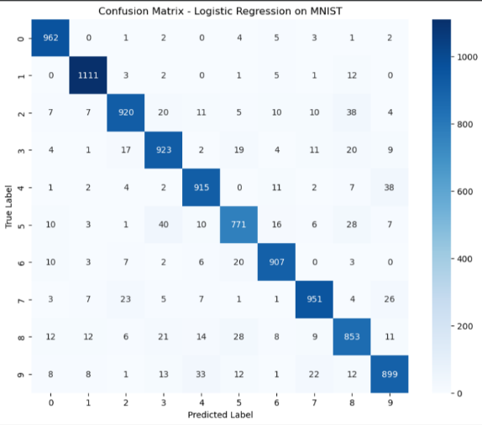
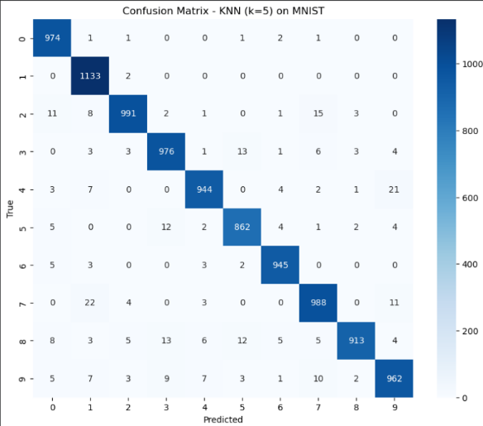
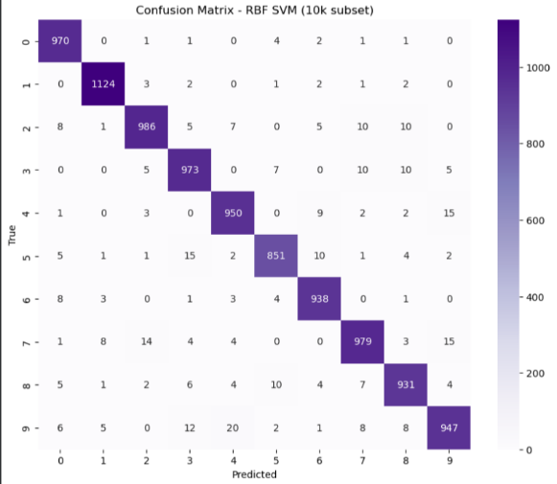
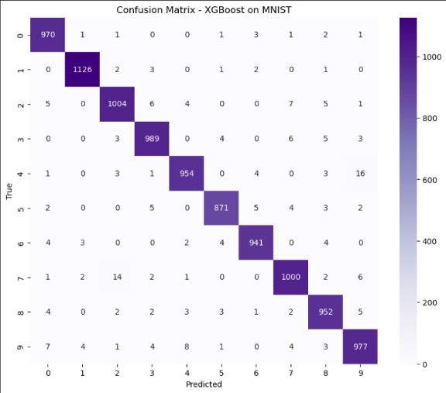
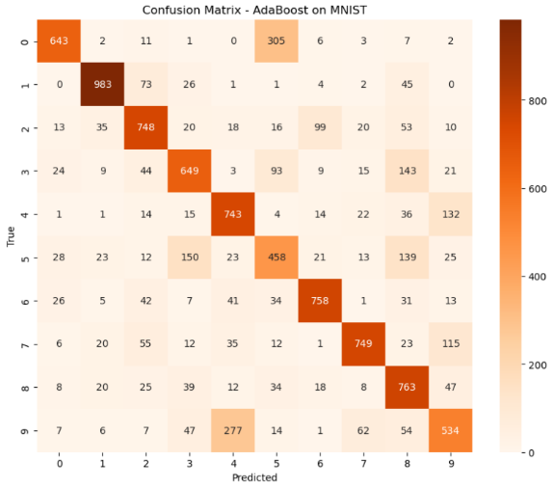
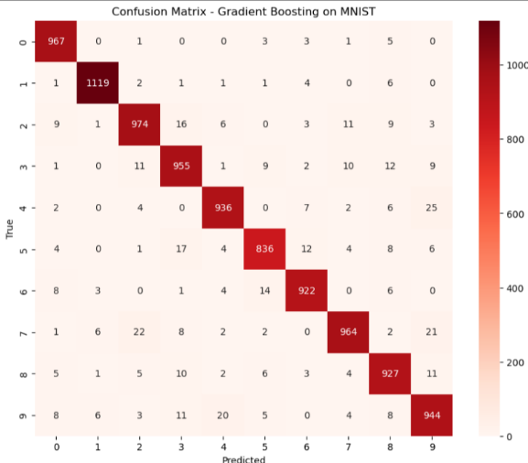
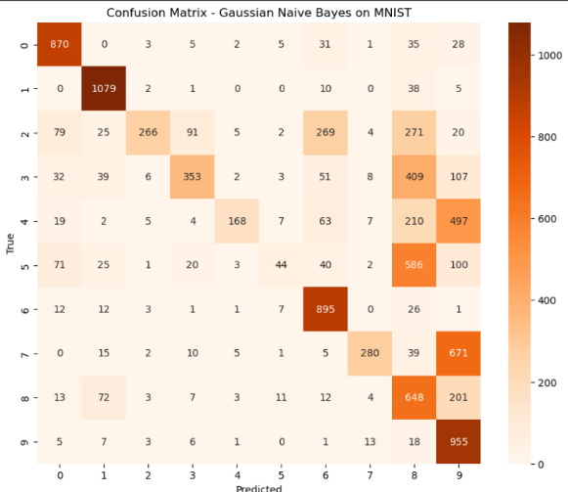
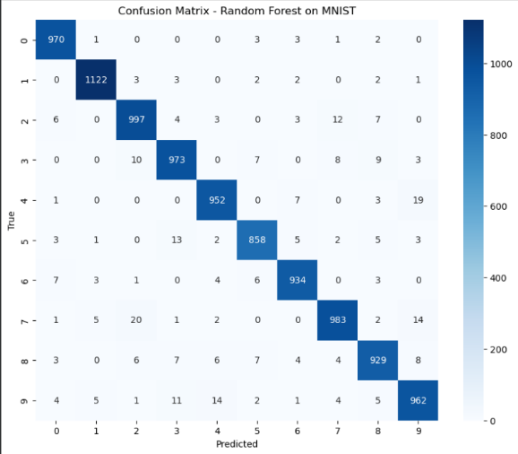
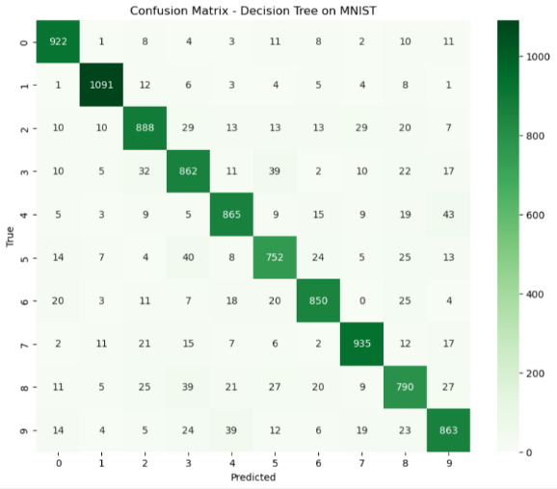

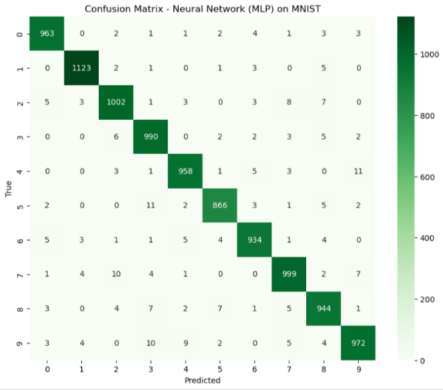

RESULTS

ACCURACY comparison
